**Bus ticket reservation**

**Class diagram**

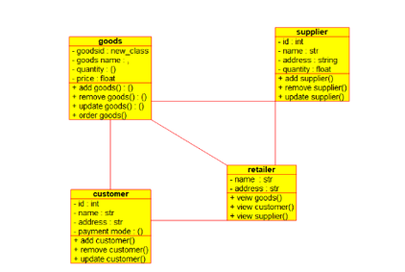

**Collaboration diagram**

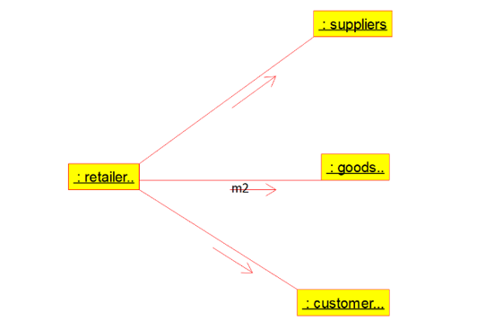

**Component diagram**

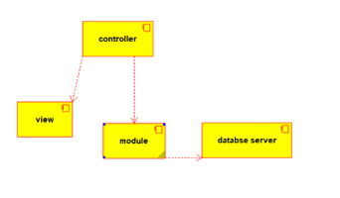

**Deployment diagram**

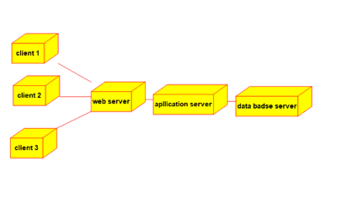

**Sequence diagram**

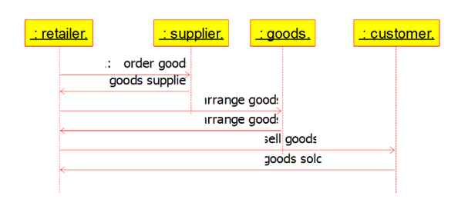

**Usecase diagram**

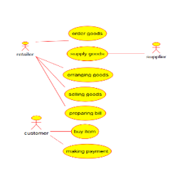

**State chart diagram**

